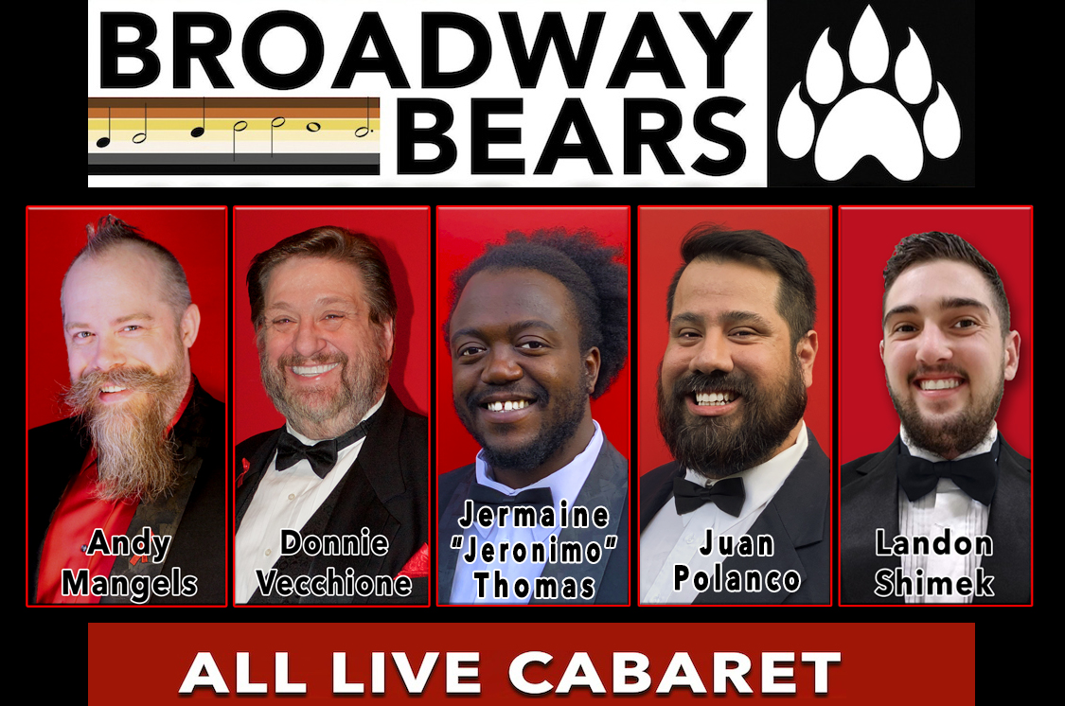
FOR IMMEDIATE RELEASE
Contact: Andy Mangels, Event Producer
webmaster@broadwaybears.org
www.BroadwayBears.org

BROADWAY BEARS
“WELCOME TO THE 60’s” Live Concert
November 20, 2022
www.BroadwayBears.org

Returning LIVE To Portland Stages November 20, 2022
Portland’s Furriest Night Of Musical Fun!
Live singing from stage and screen musicals!
"WELCOME TO THE 60’s " showcases the BROADWAY BEARS
performing some the most groovy and far-out showtunes ever sung!

PORTLAND, Oregon (October 20, 2022) – Don’t be a square! Get ready for a night of song, dance, humor, and fantastic live performances from Portland's Furriest Singers, as the BROADWAY BEARS, debut their new concert at the Funhouse Lounge on November 20, 2022! Titled “WELCOME TO THE 60’s,” the BROADWAY BEARS will perform funny, far-out, groovy, and rockin’ songs from the musical realm of stage and screen, in their trademark entertaining way… complete with furry faces! And this time, they've got some first class friends from Portland's music realm to share the stage!

The BROADWAY BEARS, “Portland's Furriest Singers,” are Andy Mangels, Donnie Vecchione, Landon Shimek, Jermaine "Jeronimo" Thomas, and Juan Polanco. For this concert, special guests from Portland's performing elite will include far out emcee Howard Neal, superstar Laurie Kash, splashy songstress Rebecca Raccinelli, and delicious diva Gabi Marcus!

With all live singing in solos, duet, trio, and group numbers, the “WELCOME TO THE 60’s” concert will be a full-length cabaret performance that will leave you laughing and cheering. The three acts feature 19 numbers that are the grooviest and hippest songs from stage productions and films such as Hairspray, 1776, It’s A Bird, It’s A Plane, It’s Superman, Hello Dolly, Sister Act, Little Shop Of Horrors, The King & I, Thoroughly Modern Millie, Mary Poppins, Cabaret, The Cher Show, Bye Bye Birdie , Hair, Tina, The Tina Turner Musical, West Side Story, Grease 2, and many more!

The concert will be at Funhouse Lounge, on November 20, 2022, with doors at 6:30pm, show from 7-9pm. Tickets are $10 General/$15 VIP in advance from www.funhouselounge.com or $15 General/$20 VIP at the door, with special reserved booth tickets also available. All Ages are welcome, but we suggest a rating of PG-13. The Broadway Bears performances at the Funhouse have been standing-room-only events, so get your tickets soon! NOTE: Due to the Covid pandemic, face masks will be requested/appreciated at the event.

The members of the BROADWAY BEARS have decades of stage experience encompassing theatrical, choral, opera, television, film, and teaching arenas. BROADWAY BEARS was co-founded in mid-2011 by Andy Mangels, and the group has performed charitable concerts and at local events in 2012-2021, including a popular and bravura opening concert at the 20th anniversary of Peacock in the Park at Washington Park Amphitheatre.

DETAILS:
BROADWAY BEARS Concert; “WELCOME TO THE 60’s”
• What: All Live Cabaret Concert with songs from Broadway and Hollywood by Portland's Furriest Singers
• When: Sunday, November 20, 2022. Doors 6:30 pm, Curtain 7:00 pm. Show ends approximately 9:00 pm.
• Where: Funhouse Lounge, 2432 SE 11th Avenue, Portland, Oregon.
• Who: The Broadway Bears are Andy Mangels, Donnie Vecchione, Landon Shimek, Jermaine "Jeronimo" Thomas, and Juan Polanco. With special guests Howard Neal, Laurie Kash, Rebecca Raccinelli, and Gabi Marcus.
• How: Tickets may be purchased at the door, or in advance from www.funhouselounge.com
• Cost: $10/$15 Advance, $15/$20 Door, with special Booth seating available. All Ages, but suggested PG-13 rating.
• Covid: Face masks will be requested/appreciated.

Photo Images and Hi-Rez Posters are at www.BroadwayBears.org/downloads.html
For additional information about the event, contact:
Andy Mangels webmaster@broadwaybears.org
# # #

